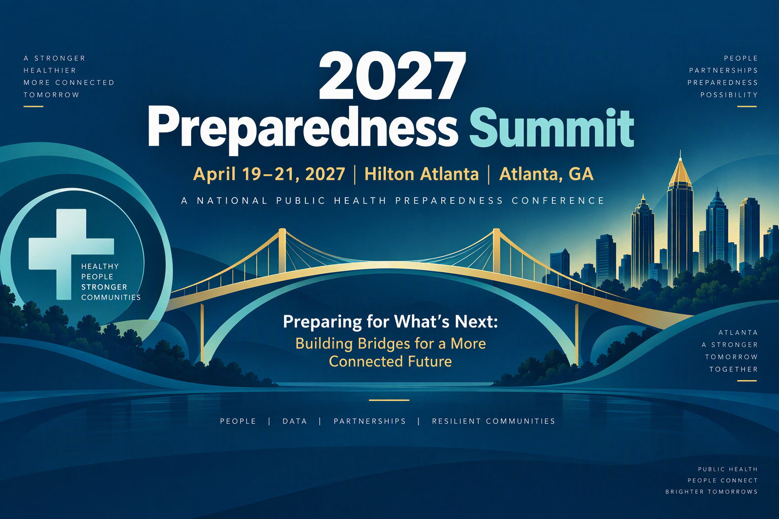
[Date]
Dear [Supervisor’s name],
I would like your approval to attend the 2027 Preparedness Summit, taking place April 19 to 21, 2027. This conference will be held at the Hilton Atlanta in Atlanta, Georgia. The Preparedness Summit is the first and longest running national conference on public health preparedness. The conference presents new research findings, shares tools and resources, and provides a variety of opportunities for attendees to learn how to implement model practices that enhance the nation’s capabilities to prepare for, respond to, and recover from disasters and other emergencies.
Attendees will learn practical tools, strategies, and concepts that demonstrate the latest effective methods to confront the ongoing public health challenges facing our governmental public health workforce today. This year’s conference will include more than 100 sharing sessions, live plenaries, Town Halls, and workshops; networking opportunities; and an exhibit hall featuring exhibitors showcasing services and products tailored for public health professionals and their agencies.
The Preparedness Summit will help me to bring timely and relevant scientific information back to my day-to-day work. This year’s theme, Preparing for What’s Next: Building Bridges for a More Connected Future, speaks directly to the importance of strengthening connections across public health, healthcare, emergency management, EMS, laboratories, academia, community-based organizations, private industry, critical infrastructure, and other partners. The Summit will focus on building a more coordinated, resilient, and unified preparedness ecosystem—one that helps the field adapt to new expectations around coordination, data sharing, risk communication, community engagement, operational decision-making, and cross-sector collaboration while sustaining the core capabilities that support readiness and response. As an attendee, I will learn directly from experts in the field and expand my professional network.
I plan to achieve the following objectives:
- [Insert your first objective here.]
- [Insert your second objective here.]
- [Insert your third objective here.]
The registration fee is <$xxx> [registration prices can be found here: XXXXXX].
The total costs for me to participate in the Preparedness Summit, including the conference fee, housing, and transportation is: <$xxx>.
Again, I believe the knowledge and professional contacts I would gain at 2027 Preparedness Summit would be invaluable to our organization and would help us strengthen our work.
Sincerely,
[Your Name]

